EECS 351

Introduction to Computer Graphics

Project A

Rotating Snowman Using WebGL

Instructor: Prof. John Timblin

Name: Ang Shen

NETID: asi031

02/05/2015

**Introduction**

In this project, a snow scene is drawn using WebGL and HTML-5 on a browser. A snowman is drawn on Canvas with animation and user control. The main goal of this project is getting to know interactive techniques of WebGL functions and draw different 3D objects based on given codes. Different shapes of 3D objects will be colored according to required design. In addition, mouse control and keyboard control will be employed to archive interaction with users.

**User Guide**

Part I Without Control

The browser shows a snowman whose body and head turns around automatically with a constant speed. In addition, a tree is drawn on the Canvas as well. The tree rotates along y-axis over time. The size and the shape of the tree is changed over time as well. A snow background is loaded behind it. At the left side of the browser, build-in buttons and instructions for HELP manual will be shown as well.

Part II User Control

* On the left side of the screen, **Spin<<** and **Spin>>** will increase or decrease the spinning speed of the snowman. Same functionality can be achieved by pressing **‘+’** and **‘-’** on the keyboard.
* Click **Run/Stop** is used to pause the snowman.
* Press **‘H’** key on the keyboard to get the brief user control manual.
* Press **Up** and **Down** to zoom in and out the snowman.
* Press **Left** and **Right** to rotation the snowman along Y-axis.
* Drag mouse to move the snowman.

**Results**

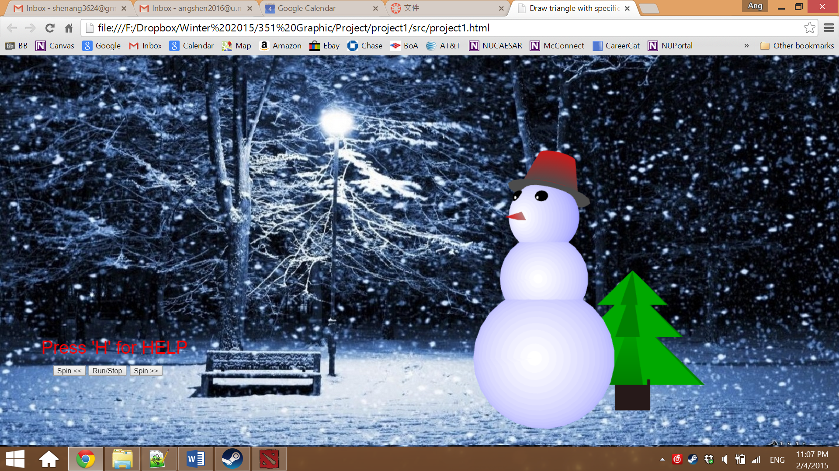

Figure 1. Initial Page

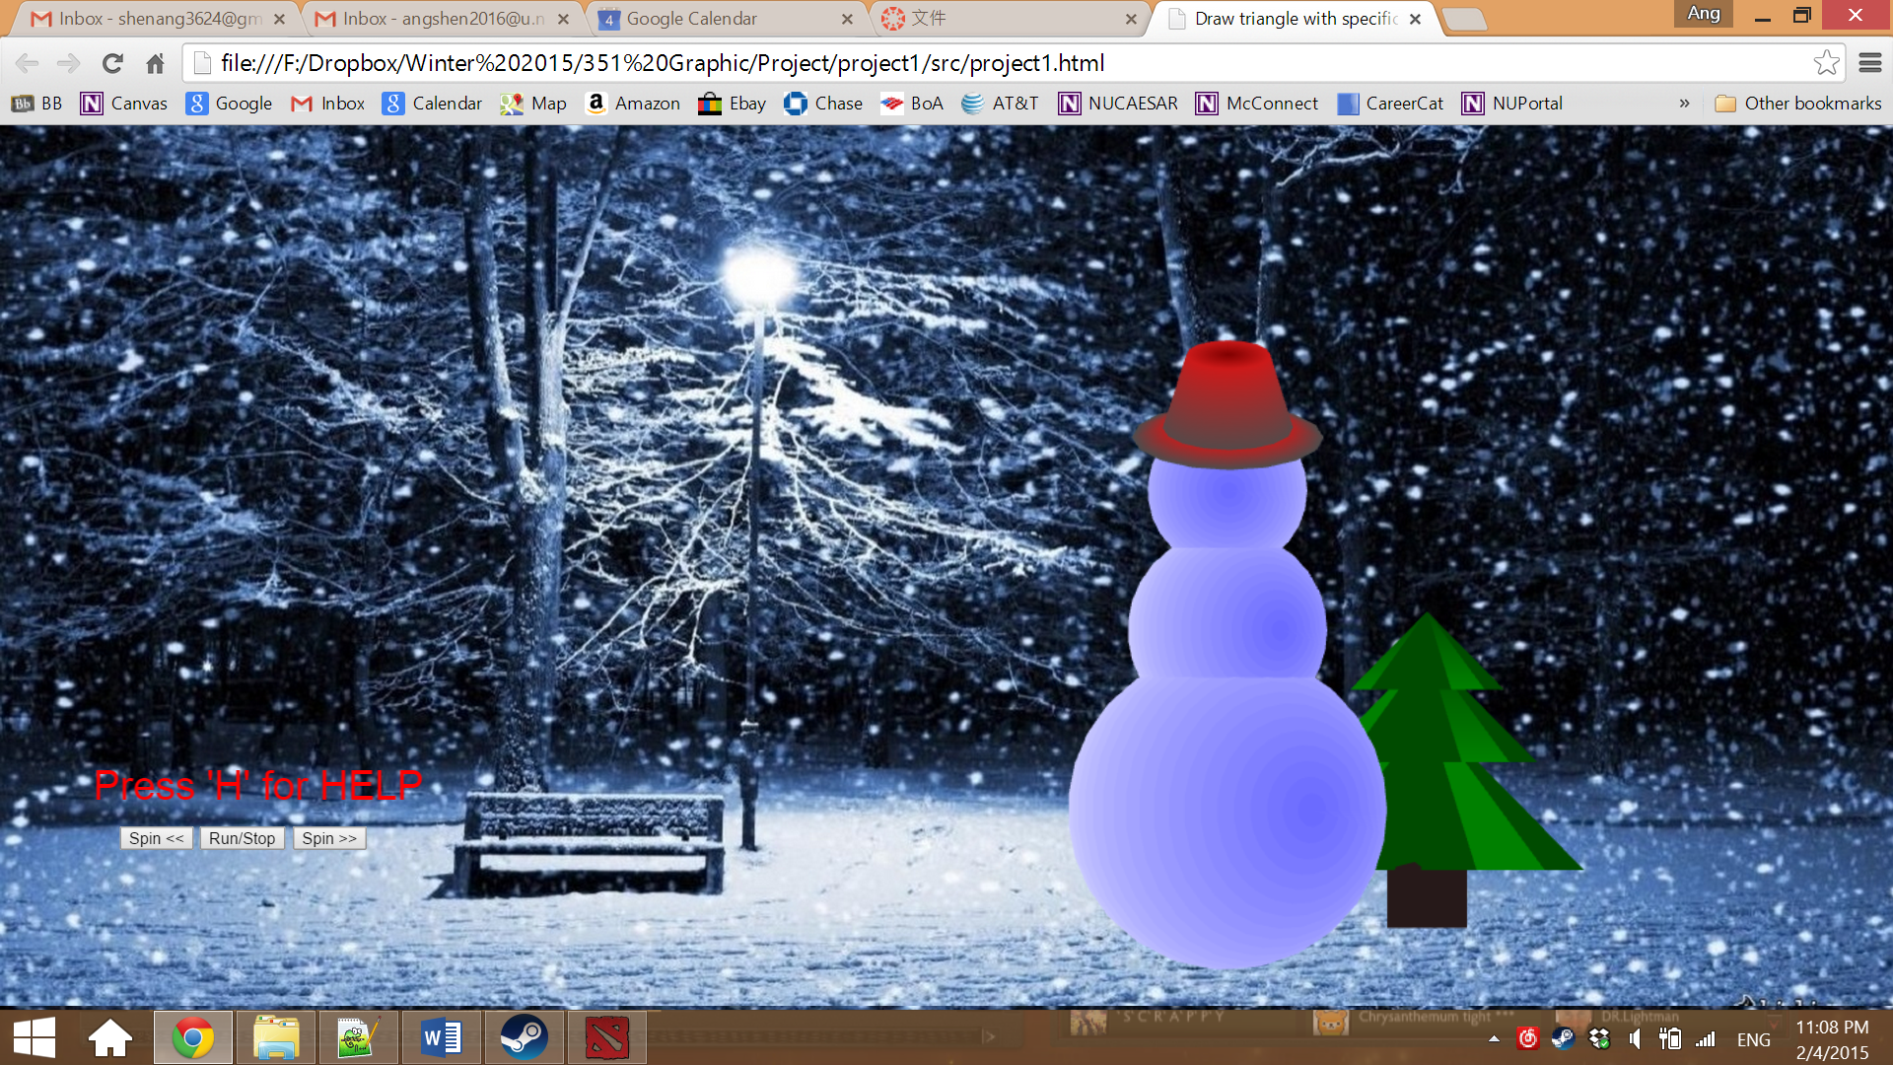

Figure 2. Snowman after rotated by pressing **LEFT** and **RIGHT** key on the keyboard

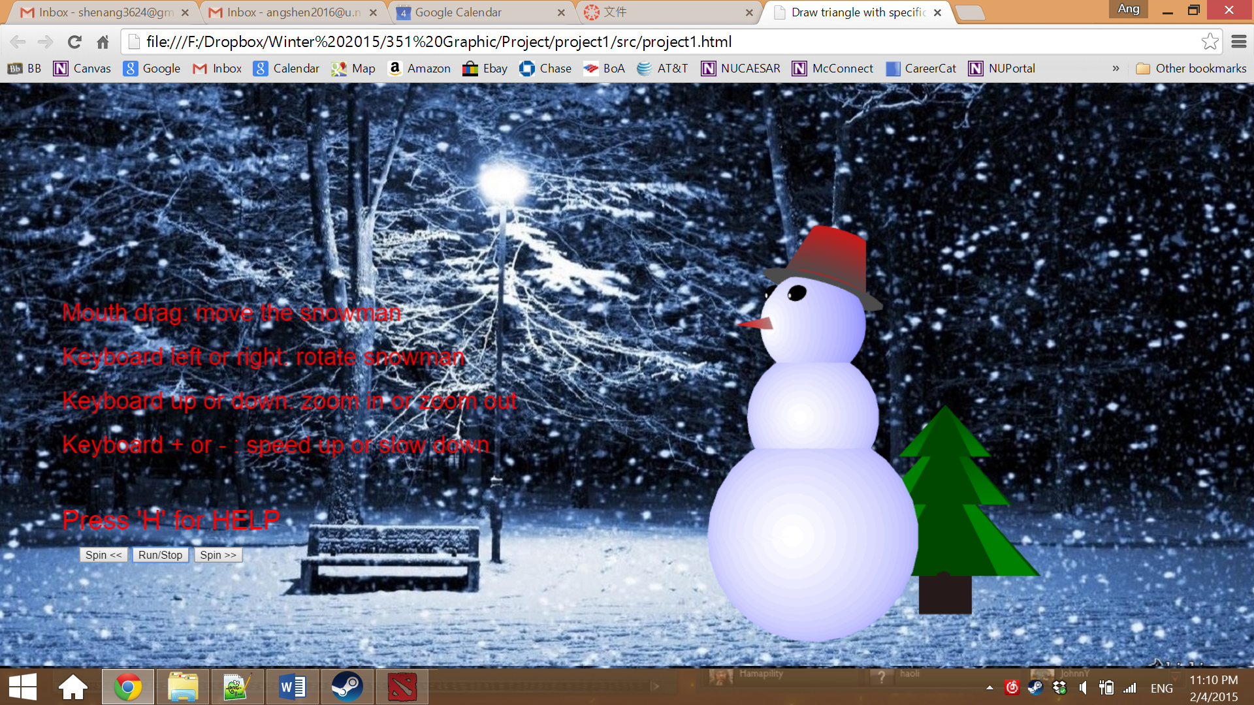

Figure 3. User guide popped up when **‘H’** is pressed

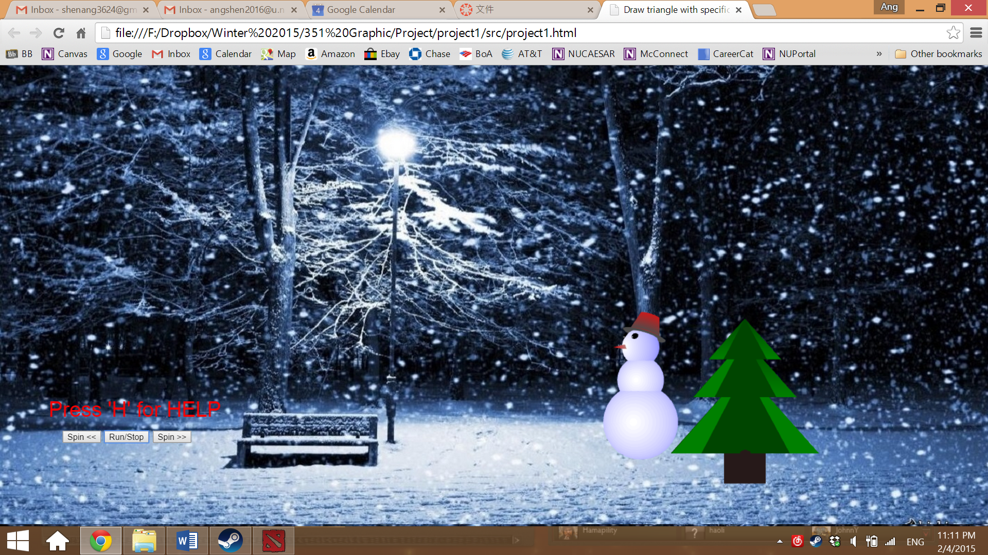

Figure 4. Snowman after scaled using **Down** and **UP** key on the keyboard

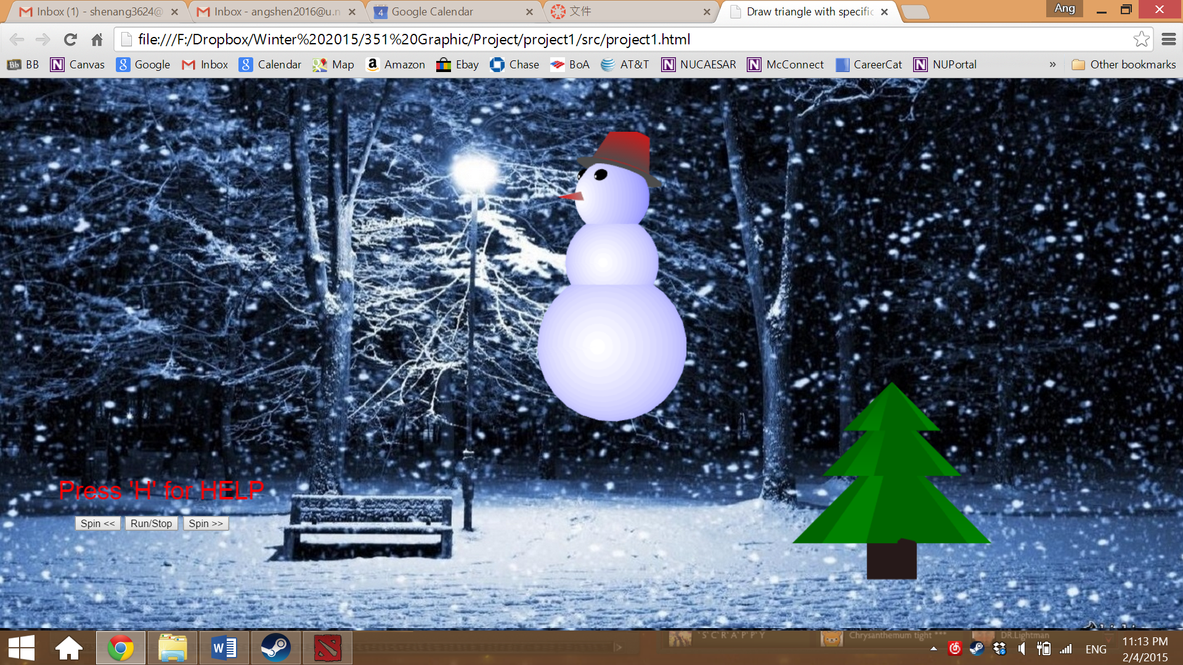

Figure 5. Snowman after moved by dragging mouse